ConnectSphere Capstone — Set 1
Prioritized Risk Analysis · Independent Cybersecurity Governance Consultant Review

Deliverable 1: Cybersecurity Governance Review Card
Section | Issue / Definition | Impact | Suggested Fix / Mitigation
1. Confidentiality Risk | PII (name, email, phone, company, title) travels between the user's browser/app and the web server over plain, unencrypted HTTP. | An attacker on the network path (e.g. public Wi-Fi) can intercept and read PII in transit (a Man-in-the-Middle attack), directly violating the Confidentiality leg of the CIA Triad and GDPR's requirement for appropriate technical safeguards. | Terminate all client connections over HTTPS/TLS; redirect HTTP to HTTPS at the load balancer and enable HSTS.
2. Integrity Risk | The second Web Server has a direct connection straight into the User Database, bypassing the API Gateway and Application Backend entirely. | Any request through this path skips whatever validation and authorization logic lives in the Application Backend, so malformed or unauthorized writes can silently corrupt user records. This is a Secure SDLC / architecture violation as much as a single bug — it creates a second, unguarded entry point into the data layer. | Remove the direct web-server-to-database connection. Force all reads/writes through the API Gateway → Application Backend, where validation and access control are enforced in one place.
3. Availability Risk | The Application Backend builds SQL queries without prepared statements, and the diagram shows two independent "User Database" instances reachable via different, inconsistent paths. | An unhandled SQL Injection attempt can, at minimum, throw errors or lock tables that degrade service, and at worst run destructive queries that take the database offline entirely — a direct Availability failure layered on top of the underlying Injection vulnerability. | Move to parameterized queries / prepared statements everywhere, and consolidate to a single, properly replicated database with one documented write-path.

Section | Metric to Monitor | Visualization Type | Why It Matters
4. Monitoring / Reporting Recommendation | Failed / unauthorized Admin Dashboard access attempts — count of requests to the admin endpoint without a valid authenticated session. | Line chart over time, with a threshold marker for alerting on spikes. | The admin dashboard is currently public with no authentication, so this metric is the only visibility into active probing today, and becomes an early-warning signal for credential attacks once authentication is added (supports OWASP A09 — Security Logging & Monitoring).

Deliverable 2: Corrected Architecture Diagram
Annotated corrections are numbered directly on the diagram below, with the full explanation of each repeated as text for the written record.
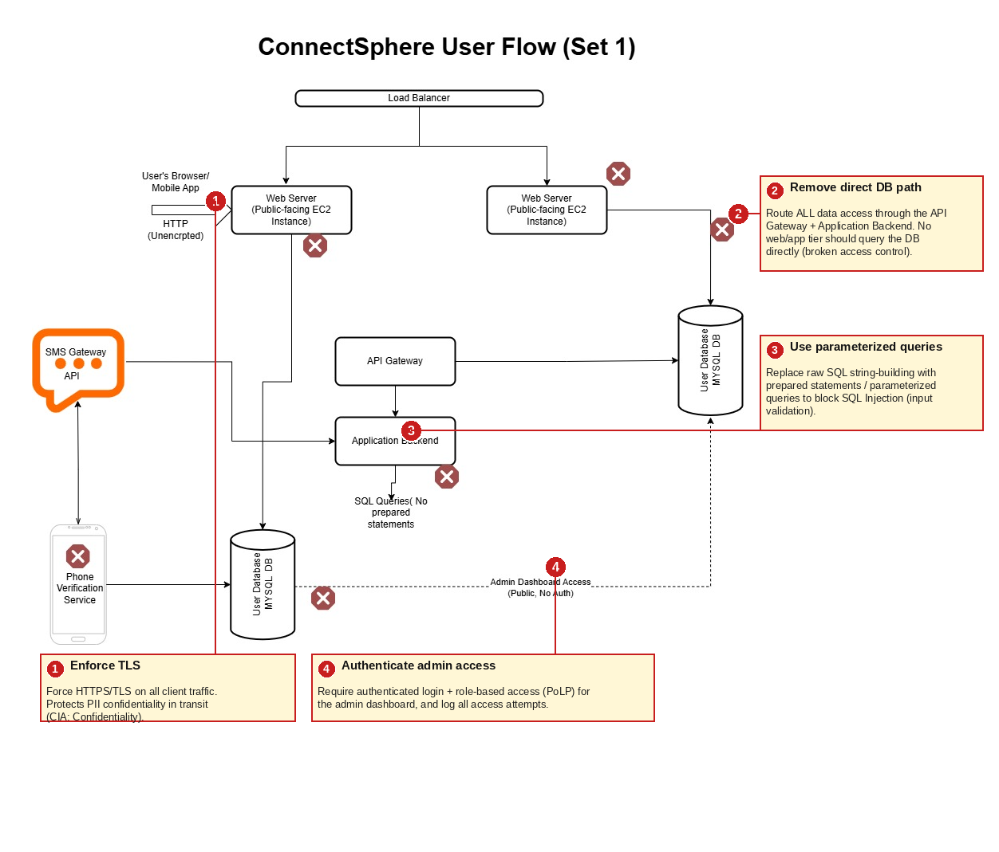
1. ① Enforce TLS — Force HTTPS/TLS on all client traffic. Protects PII confidentiality in transit (CIA: Confidentiality).
2. ② Remove direct DB path — Route all data access through the API Gateway + Application Backend. No web/app tier should query the database directly (broken access control).
3. ③ Use parameterized queries — Replace raw SQL string-building with prepared statements / parameterized queries to block SQL Injection (input validation).
4. ④ Authenticate admin access — Require authenticated login and role-based access (PoLP) for the admin dashboard, and log all access attempts.

Deliverable 3: Summary of Review Process
To review ConnectSphere's Set 1 architecture, I walked the diagram end-to-end and mapped each connection against the CIA Triad, the Principle of Least Privilege, and Secure SDLC practices, rather than treating the flagged icons as a simple checklist. The unencrypted HTTP channel was the clearest Confidentiality gap, since it exposes PII to interception in transit. The second web server's direct line into the User Database was the more subtle finding: it isn't just a vulnerability, it's an architectural violation of PoLP and Secure SDLC — any component that bypasses the Application Backend also bypasses whatever validation and authorization logic lives there, undermining Integrity even without a single obvious "bug." Missing prepared statements compound this into a concrete Injection risk that threatens Availability if exploited destructively.
From a UI/UX specialization lens, this exercise also surfaced how design and front-end decisions can leak security posture — a public, unauthenticated admin dashboard is exactly the kind of exposed surface that OSINT and Google-dorking techniques are built to find, a reminder that "hidden" internal tools still need real authentication, not just obscurity.
These findings directly improve ConnectSphere's readiness for GDPR/CCPA-style due diligence: encrypting PII in transit and locking down admin access are baseline expectations under both frameworks. The recommended monitoring metric — failed or unauthorized admin access attempts — supports transparent governance because it gives the organization, and eventually its auditors, verifiable evidence that access to sensitive systems is actively watched rather than just assumed secure.

